|  |
| --- |
|  |
| Portfolio of Evidence  WRDV301 – Database Systems 3.1 |
| |  |  |  | | --- | --- | --- | | **Surprise Mfaniseni Mhlongo (Mr.)** | **221440038** |  | |

**TABLE OF CONTENTS**

Rubrics 1

Assignment Resubmission & First Submission Rubric 1

Portfolio Rubric 1

Marks in Components 1

Class Activity Submissions 2

Normalisation 2

Mystery Murder 2

Design Example 7

Optimising Query 8

Assignment Submissions 9

Data and Relational Database Models & Relational Algebra 9

Draft Submission 9

Final Submission 11

Modelling and Normalisation 14

Draft Submission 14

Final Submission 16

SQL 18

Draft Submission 18

Final Submission 22

Database development and design & Concurrency control 26

Draft Submission 26

Final Submission 28

Managing database and SQL Performance & Distributed databases 31

Draft Submission 31

Final Submission 33

Reflection 35

# Rubrics

## Assignment Resubmission & First Submission Rubric

|  |  |  |  |  |  |  |  |
| --- | --- | --- | --- | --- | --- | --- | --- |
| **ASSIGNMENT** | **YOUR MARK** | **MAX MARK** | **CLASS AVG** | **RESUBMITion** | | **FIRST submission** | |
| a* | Mark | a* | Mark |
| **01 – 4 MAR** | 56 | 66 | 54/66 |  |  |  |  |
| **02 – 18 MAR** | 21.5 | 36 | 28/36 |  |  |  |  |
| **03 – 15 APR** | 25 | 27 | 25/27 |  |  |  |  |
| **04 – 29 APR** | 38 | 45 | 38/45 |  |  |  |  |
| **05 – 13 MAY** | 23 | 27 | 19/27 |  |  |  |  |

## Portfolio Rubric

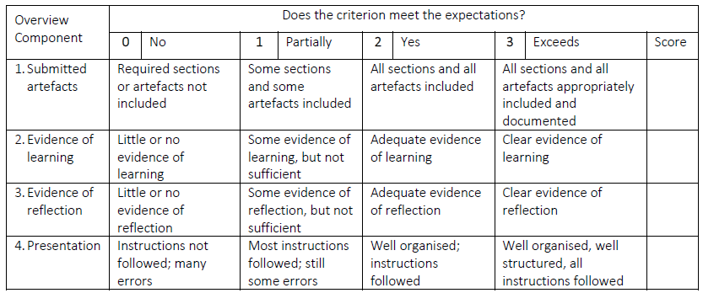

## Marks in Components

|  |  |  |
| --- | --- | --- |
| 60% Component | 40% Component | Total |
| 77* |  |  |

# Class Activity Submissions

## Normalisation



## Mystery Murder

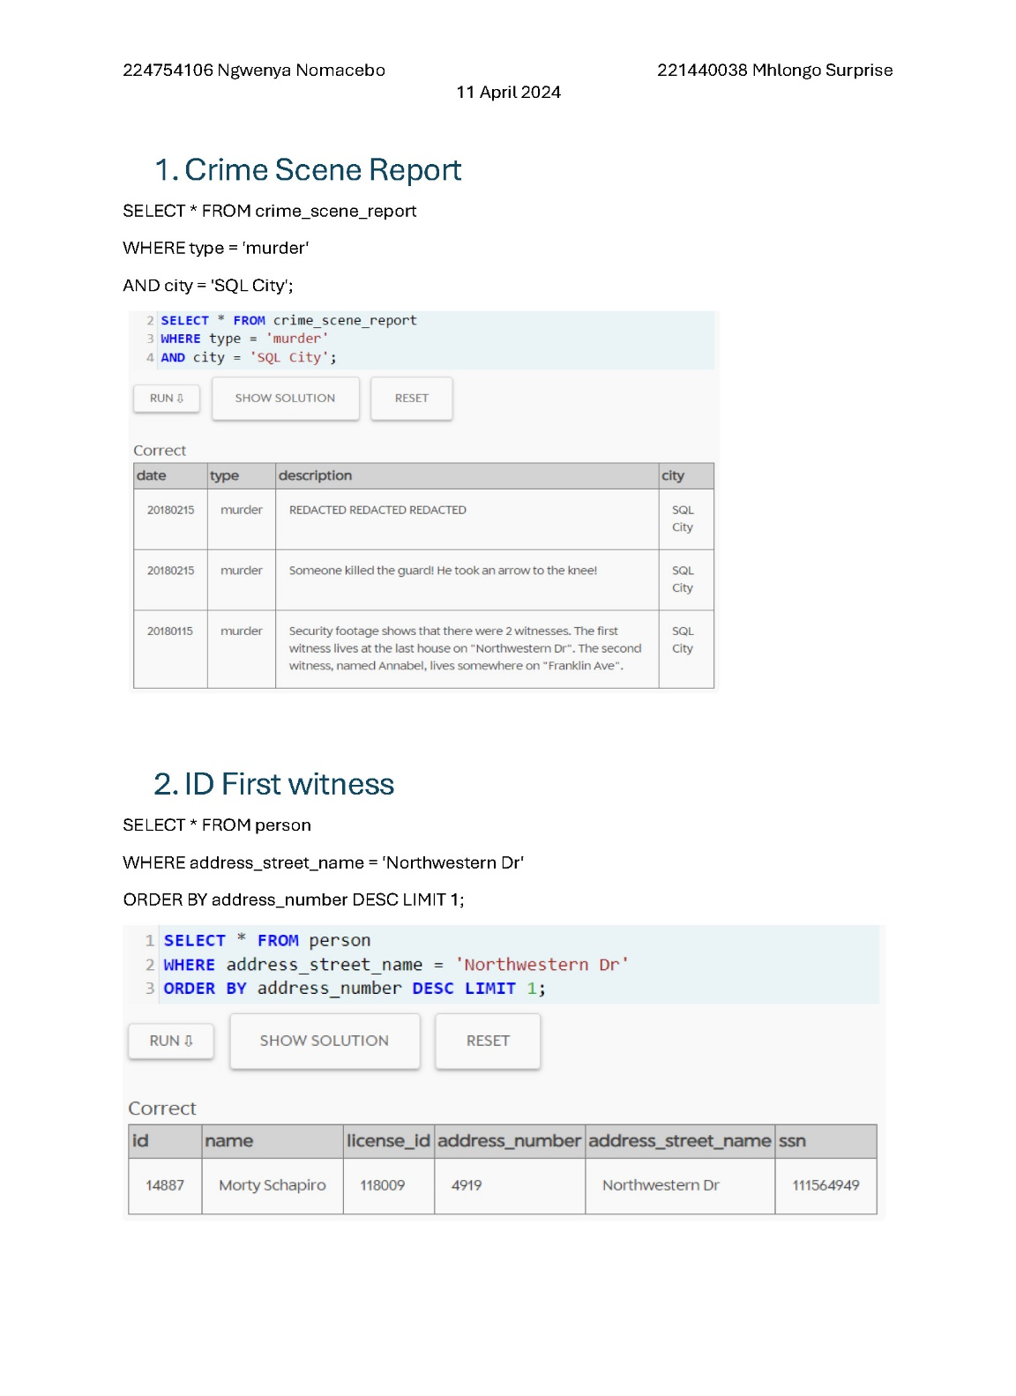  
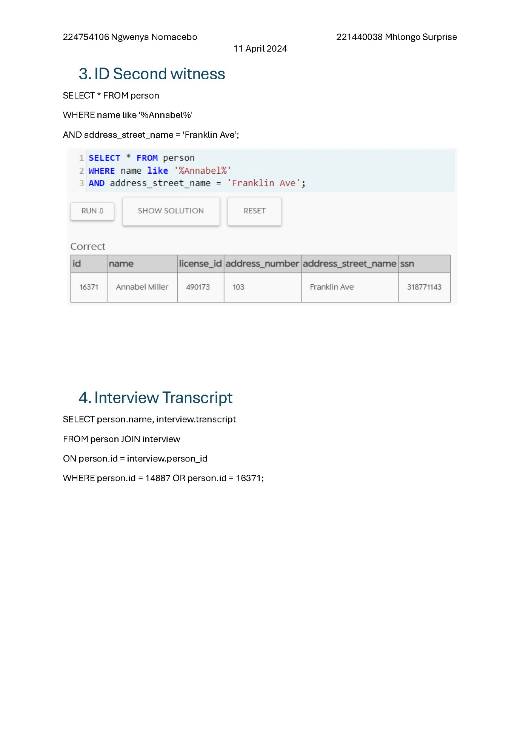

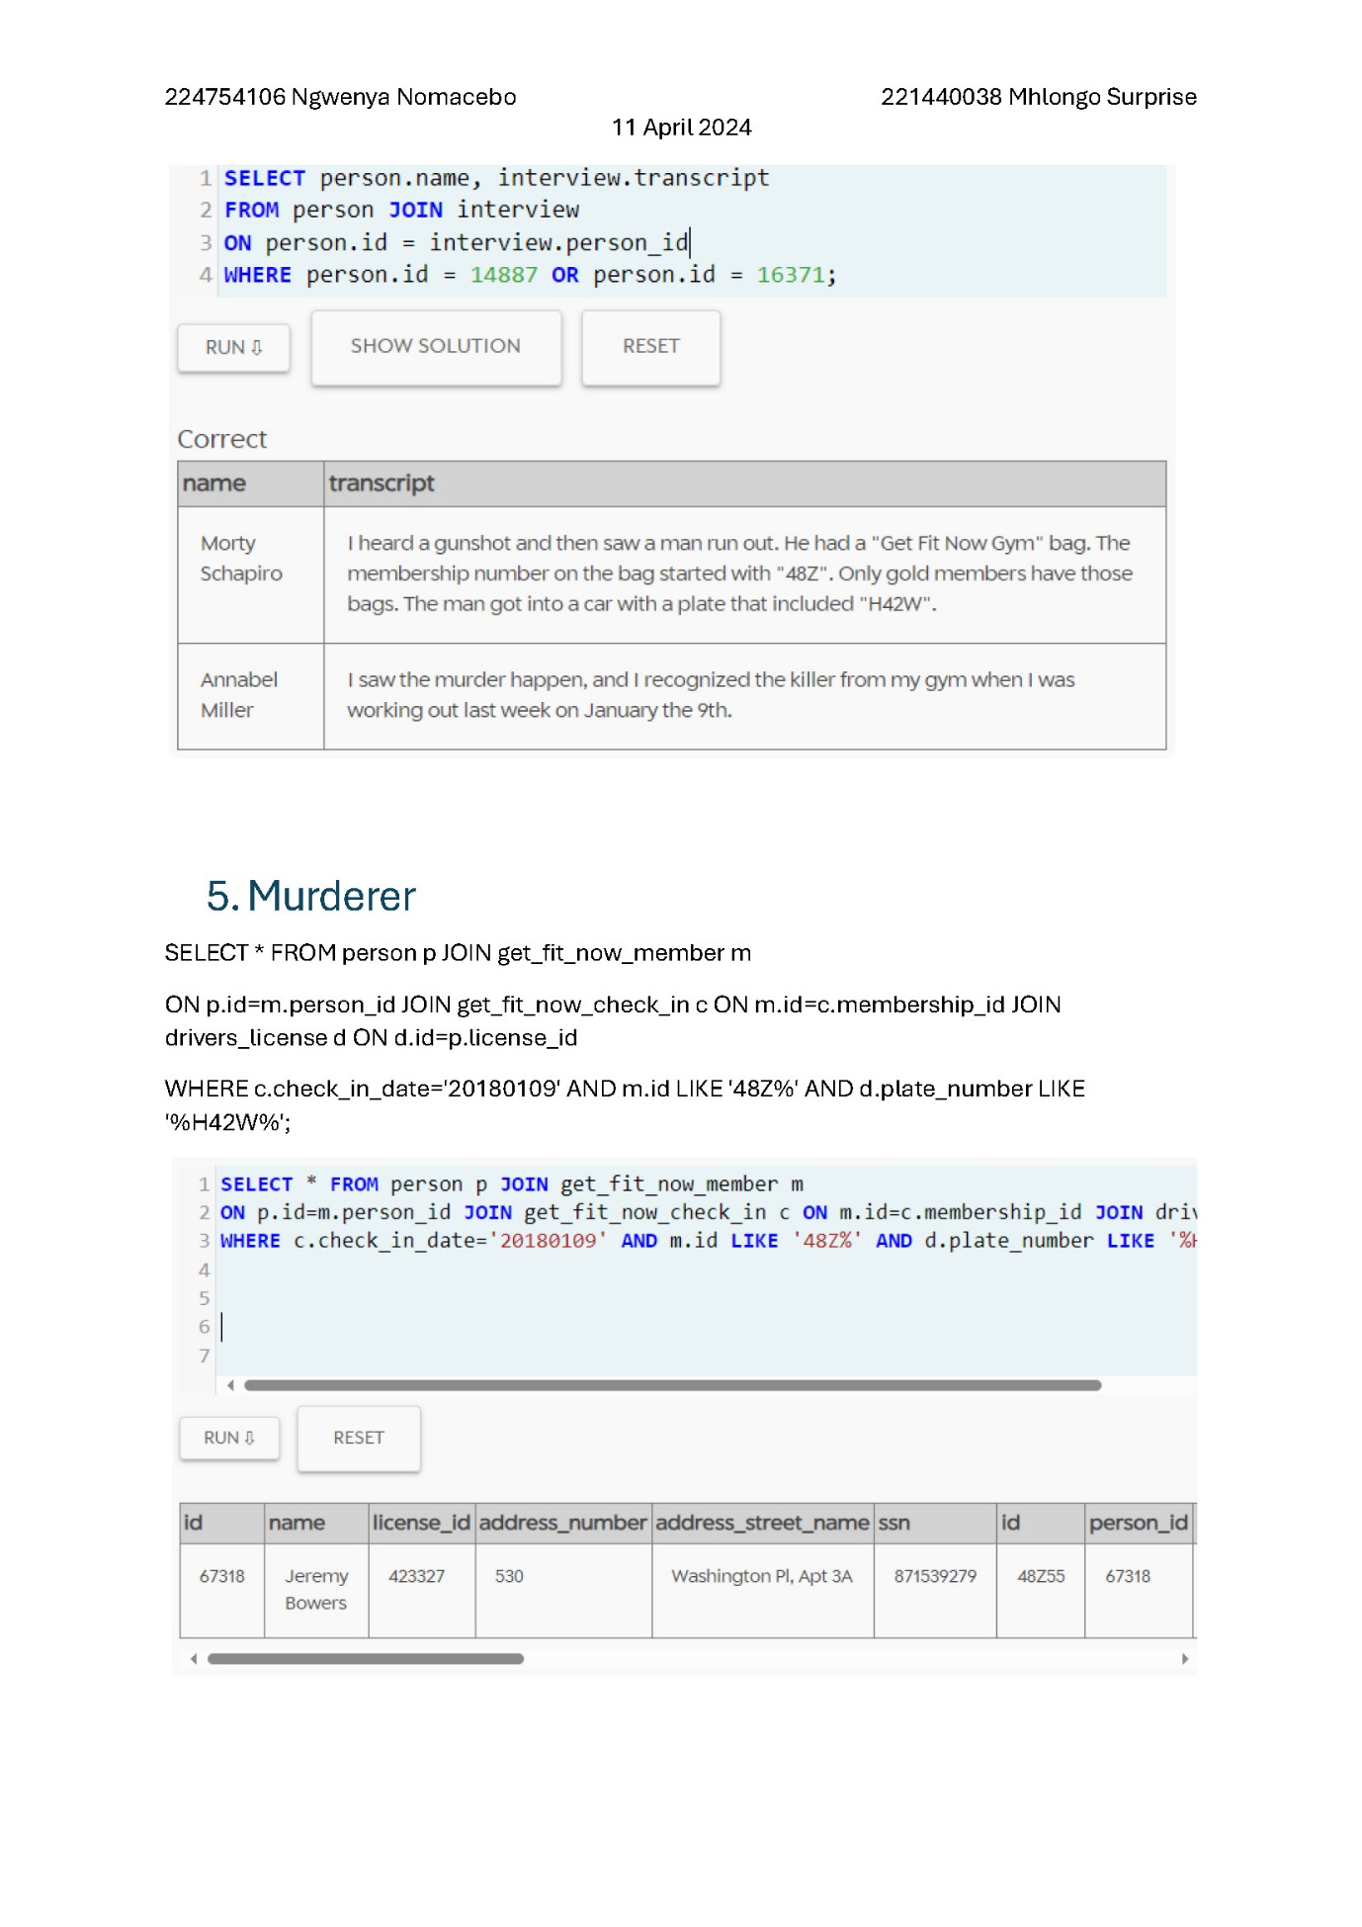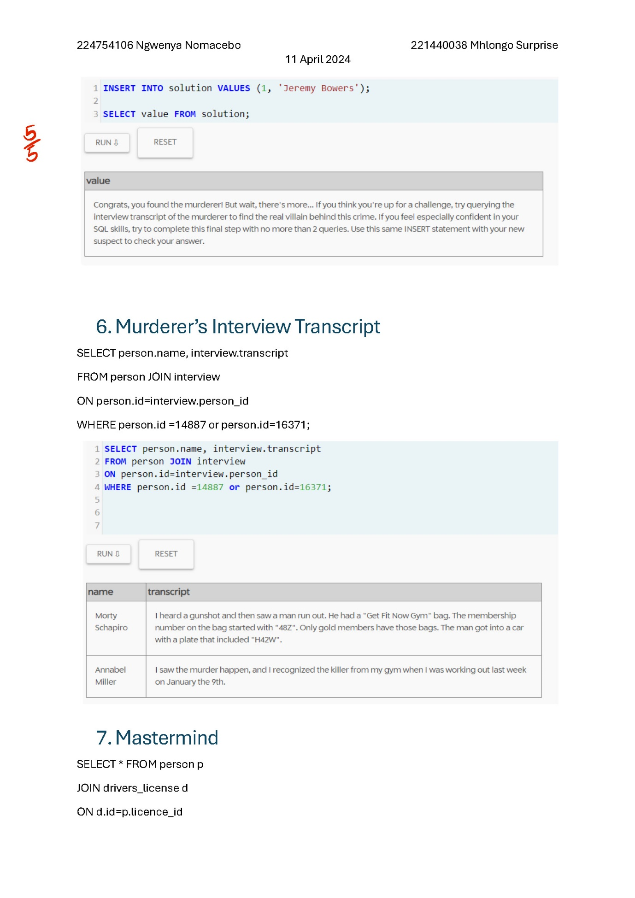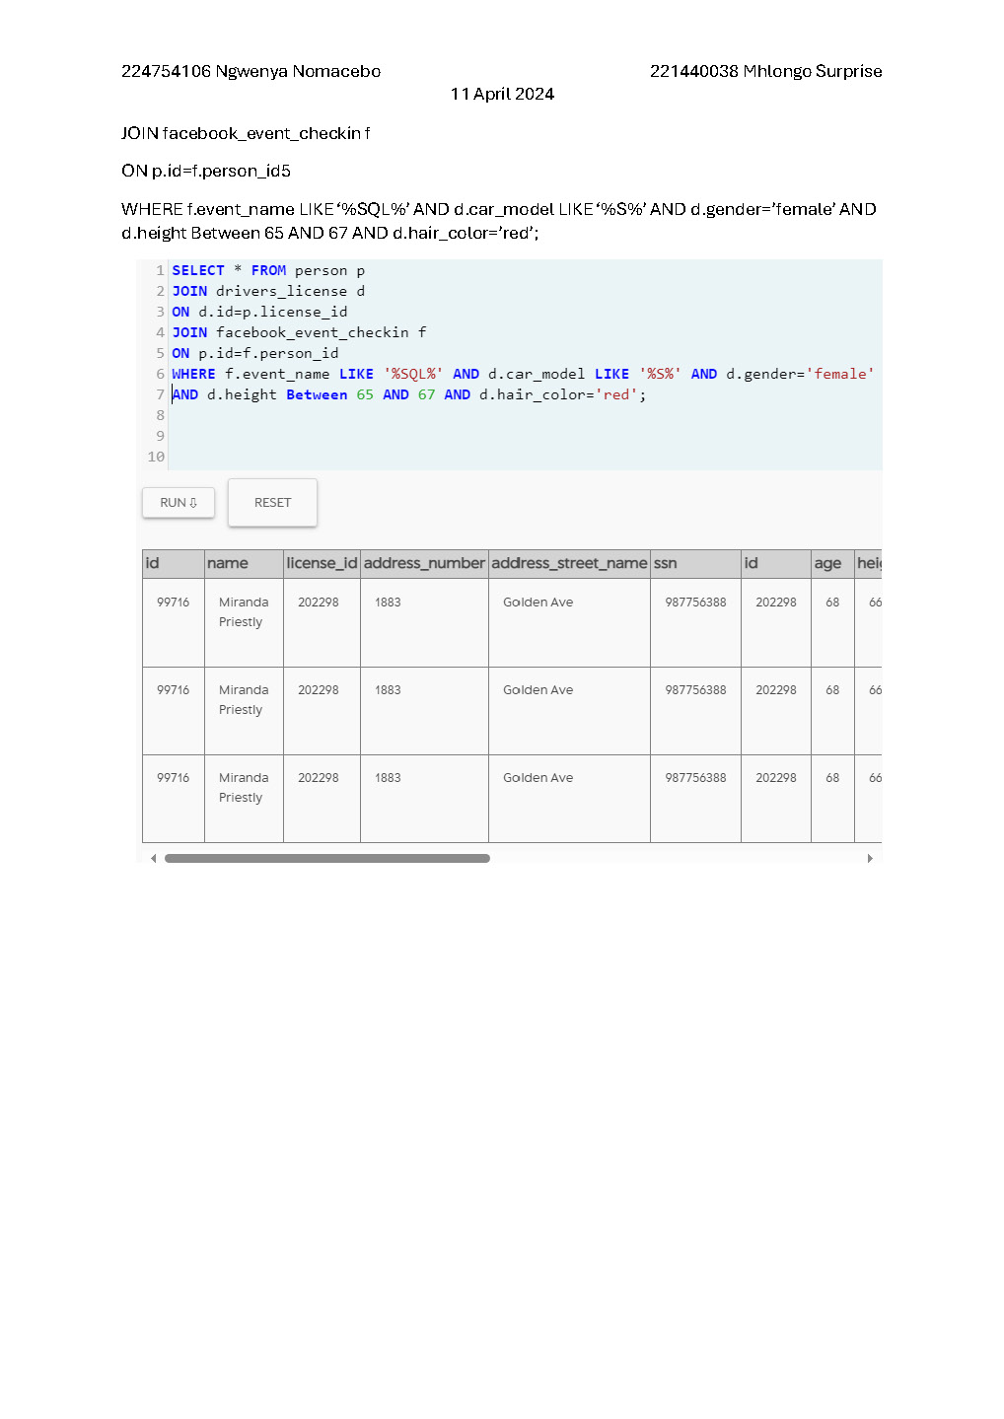

## Design Example

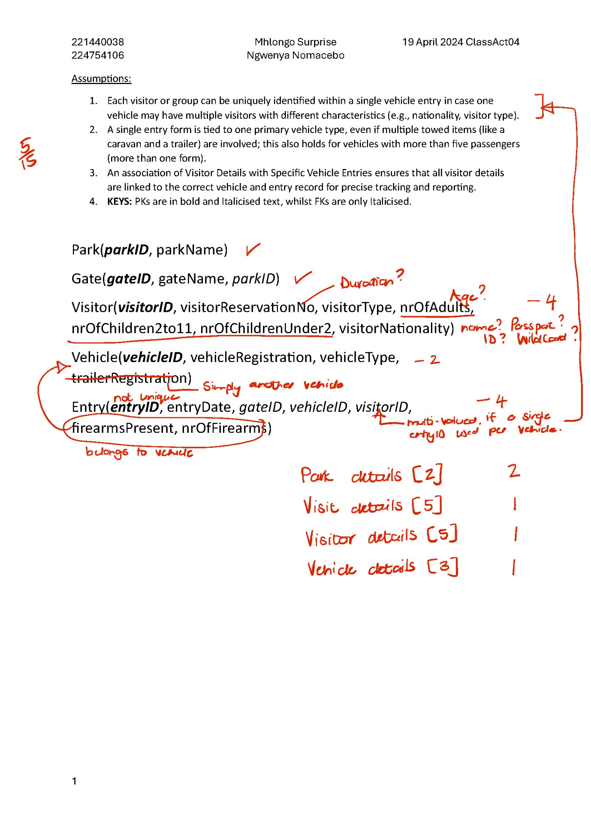

## Optimising Query

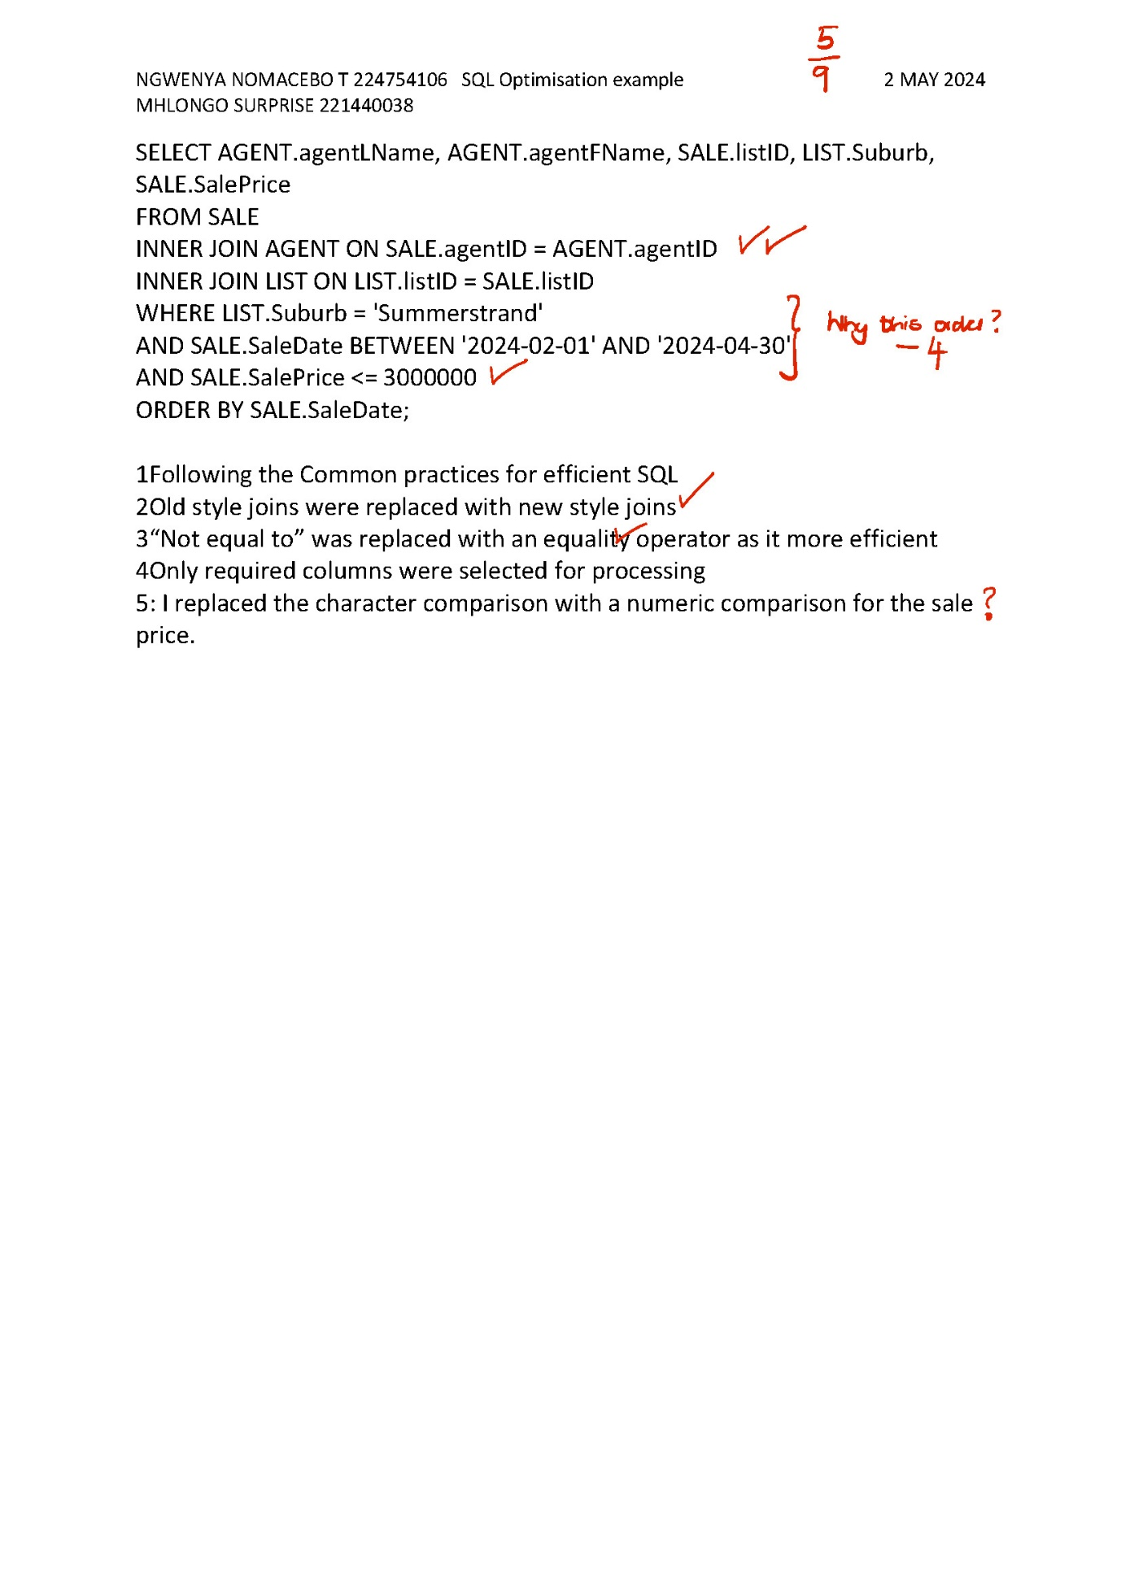

# Assignment Submissions

## Data and Relational Database Models & Relational Algebra

### Draft Submission

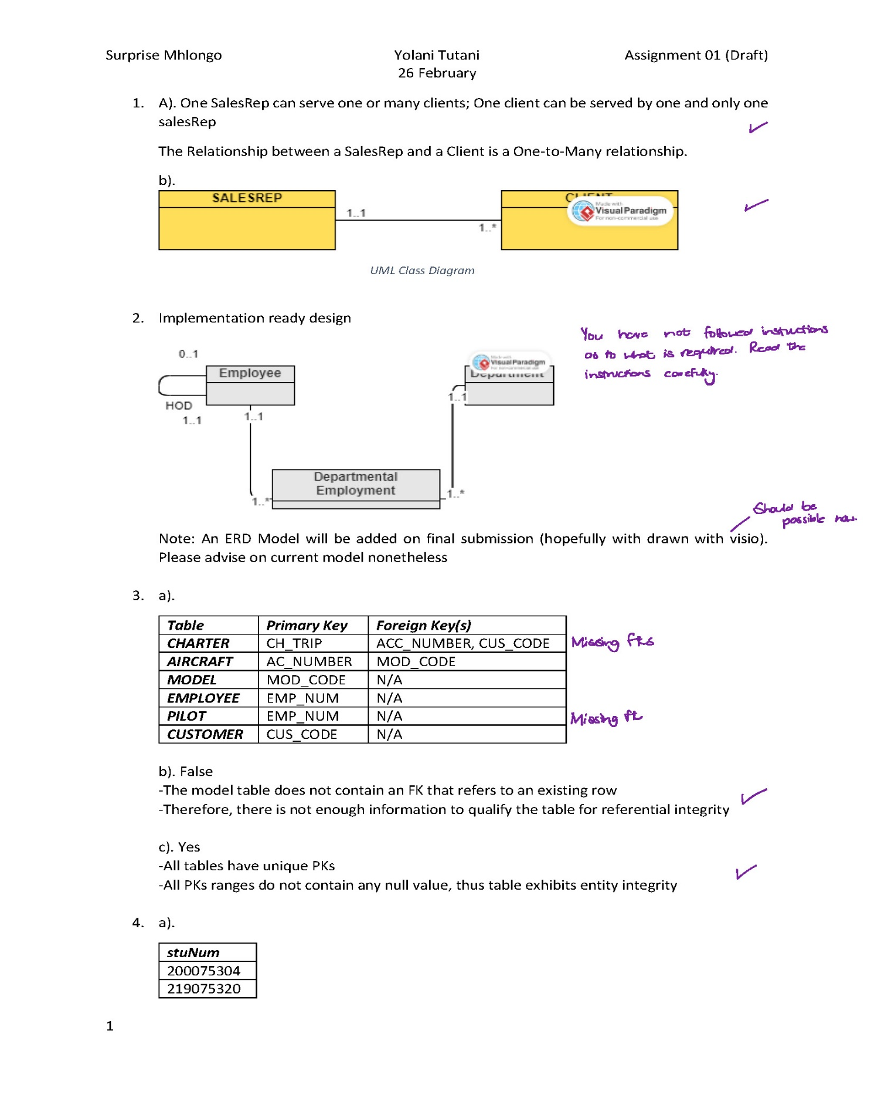

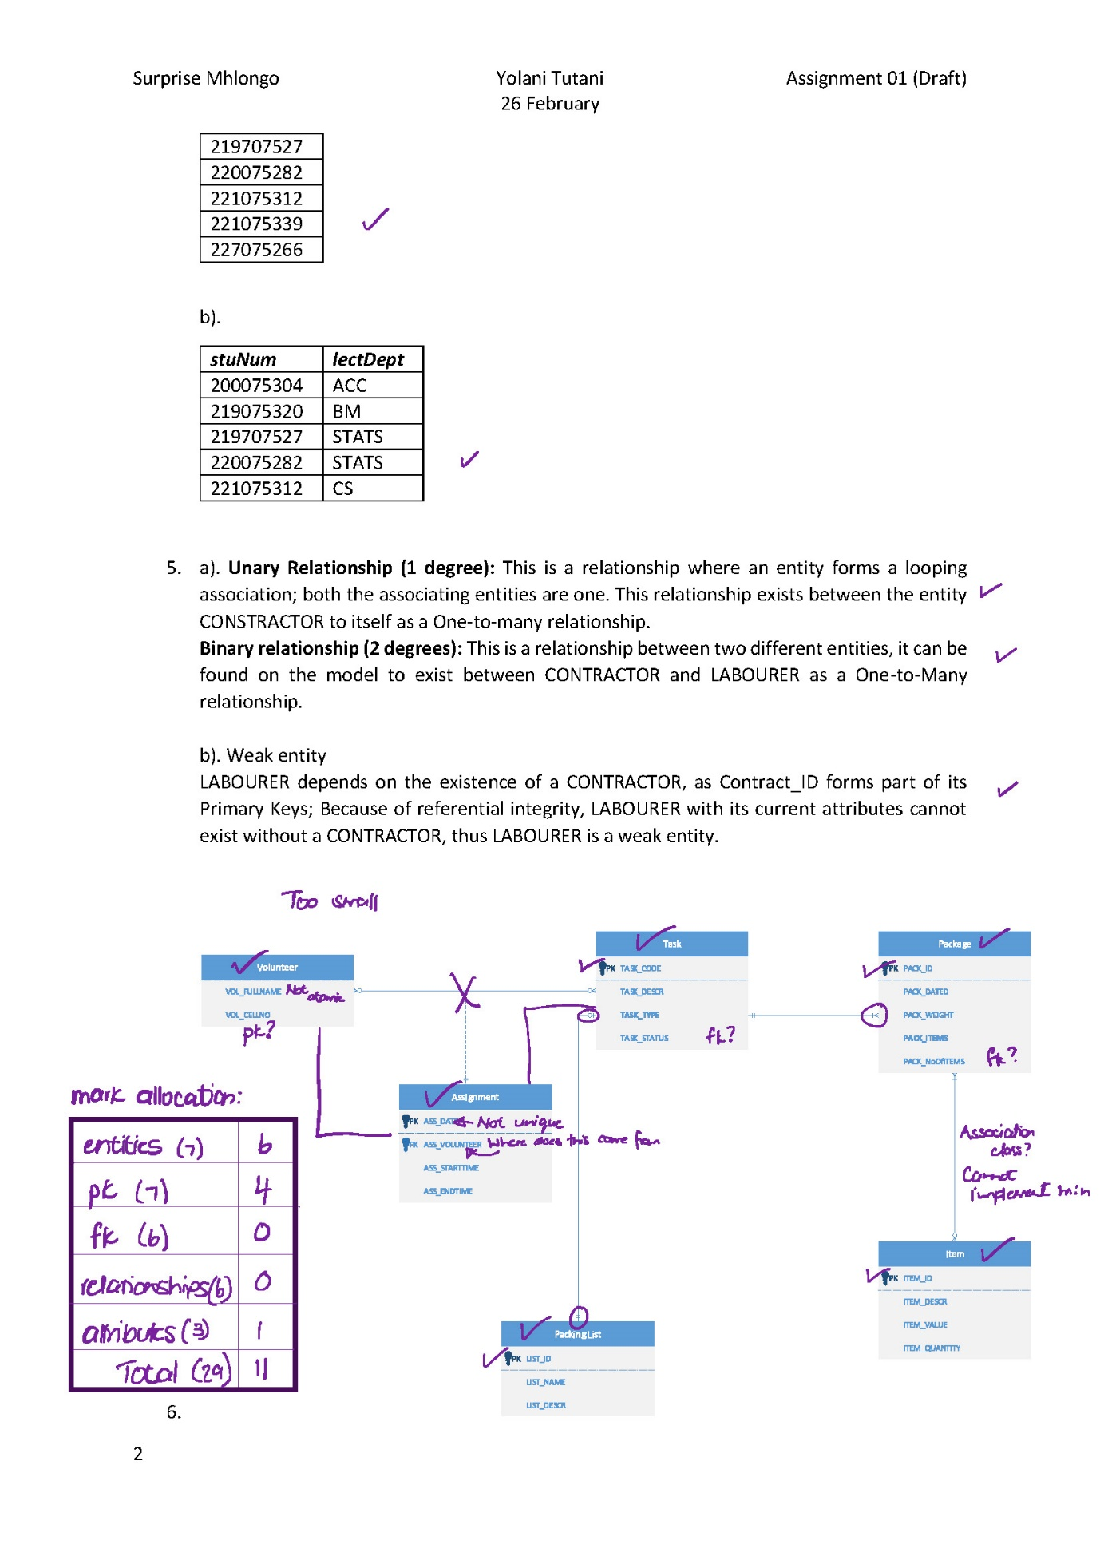

Final Submission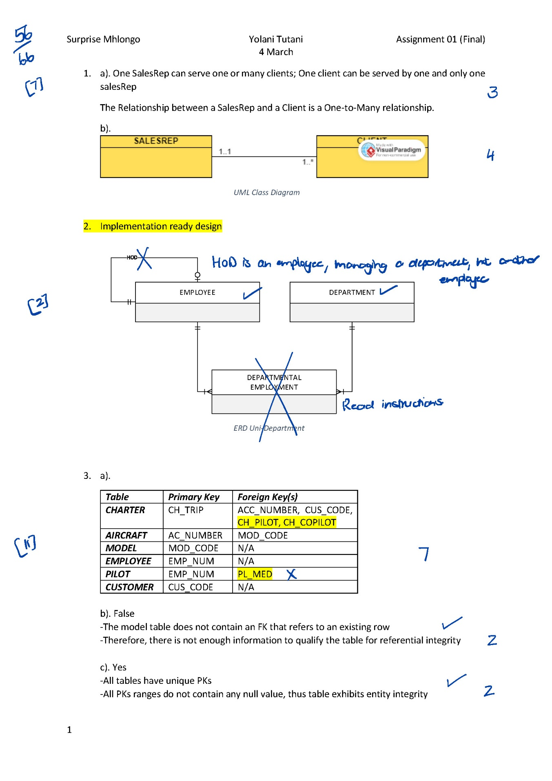

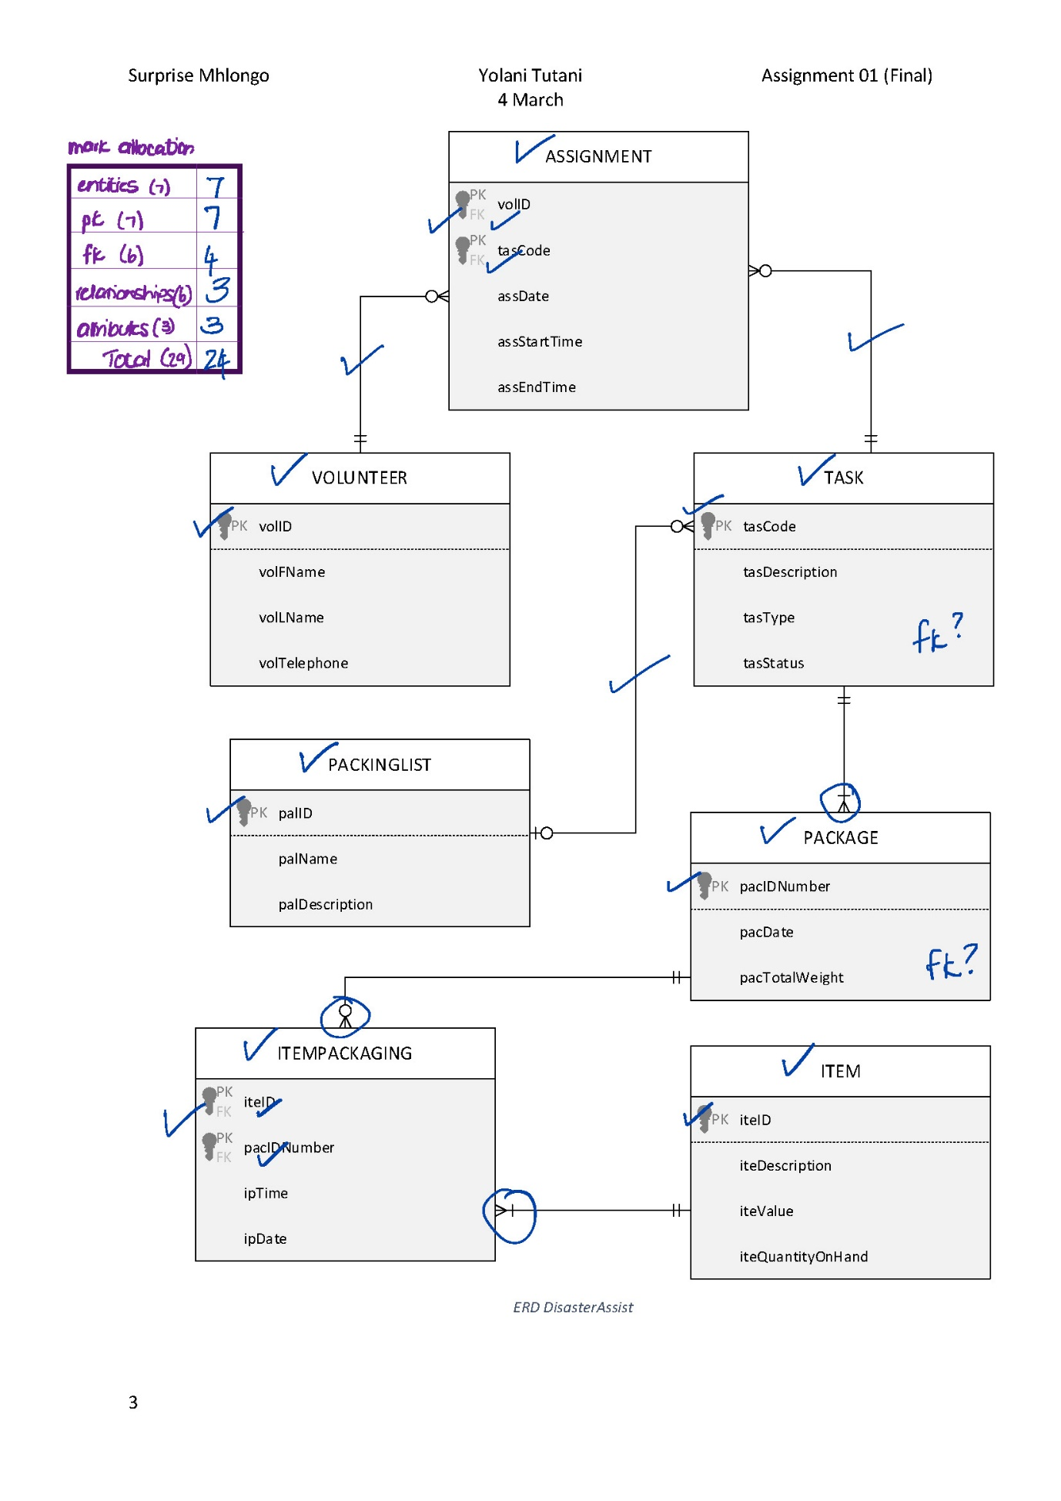

## Modelling and Normalisation

Draft Submission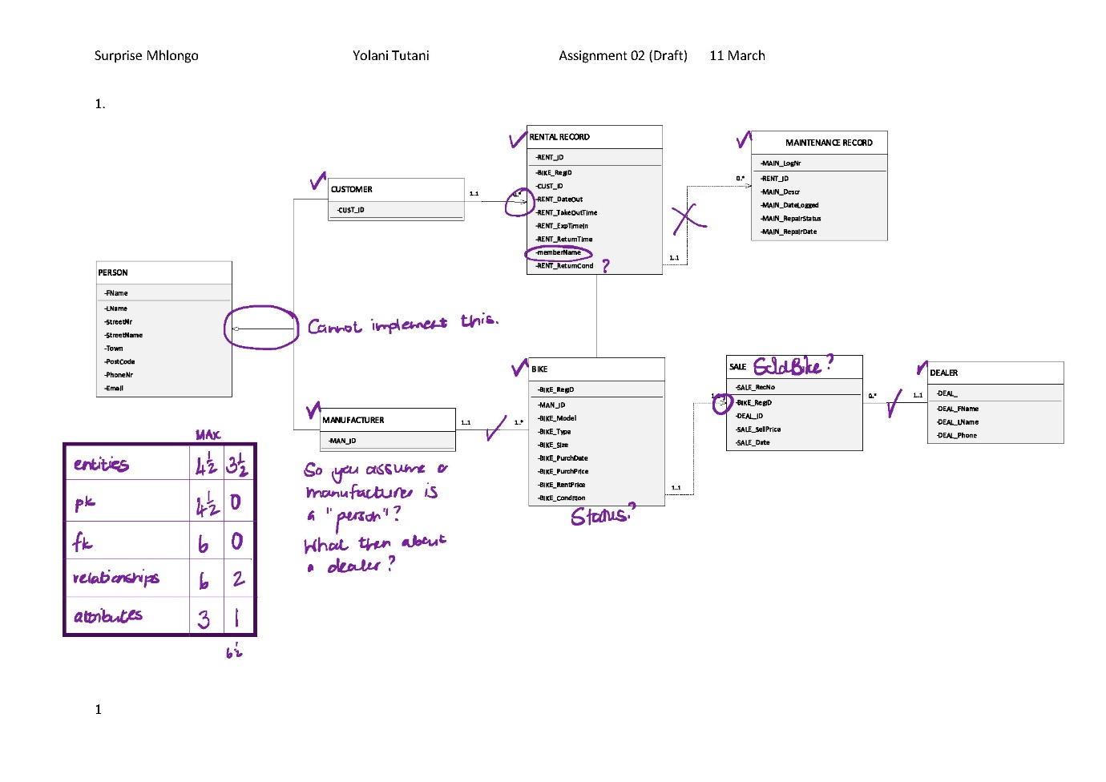

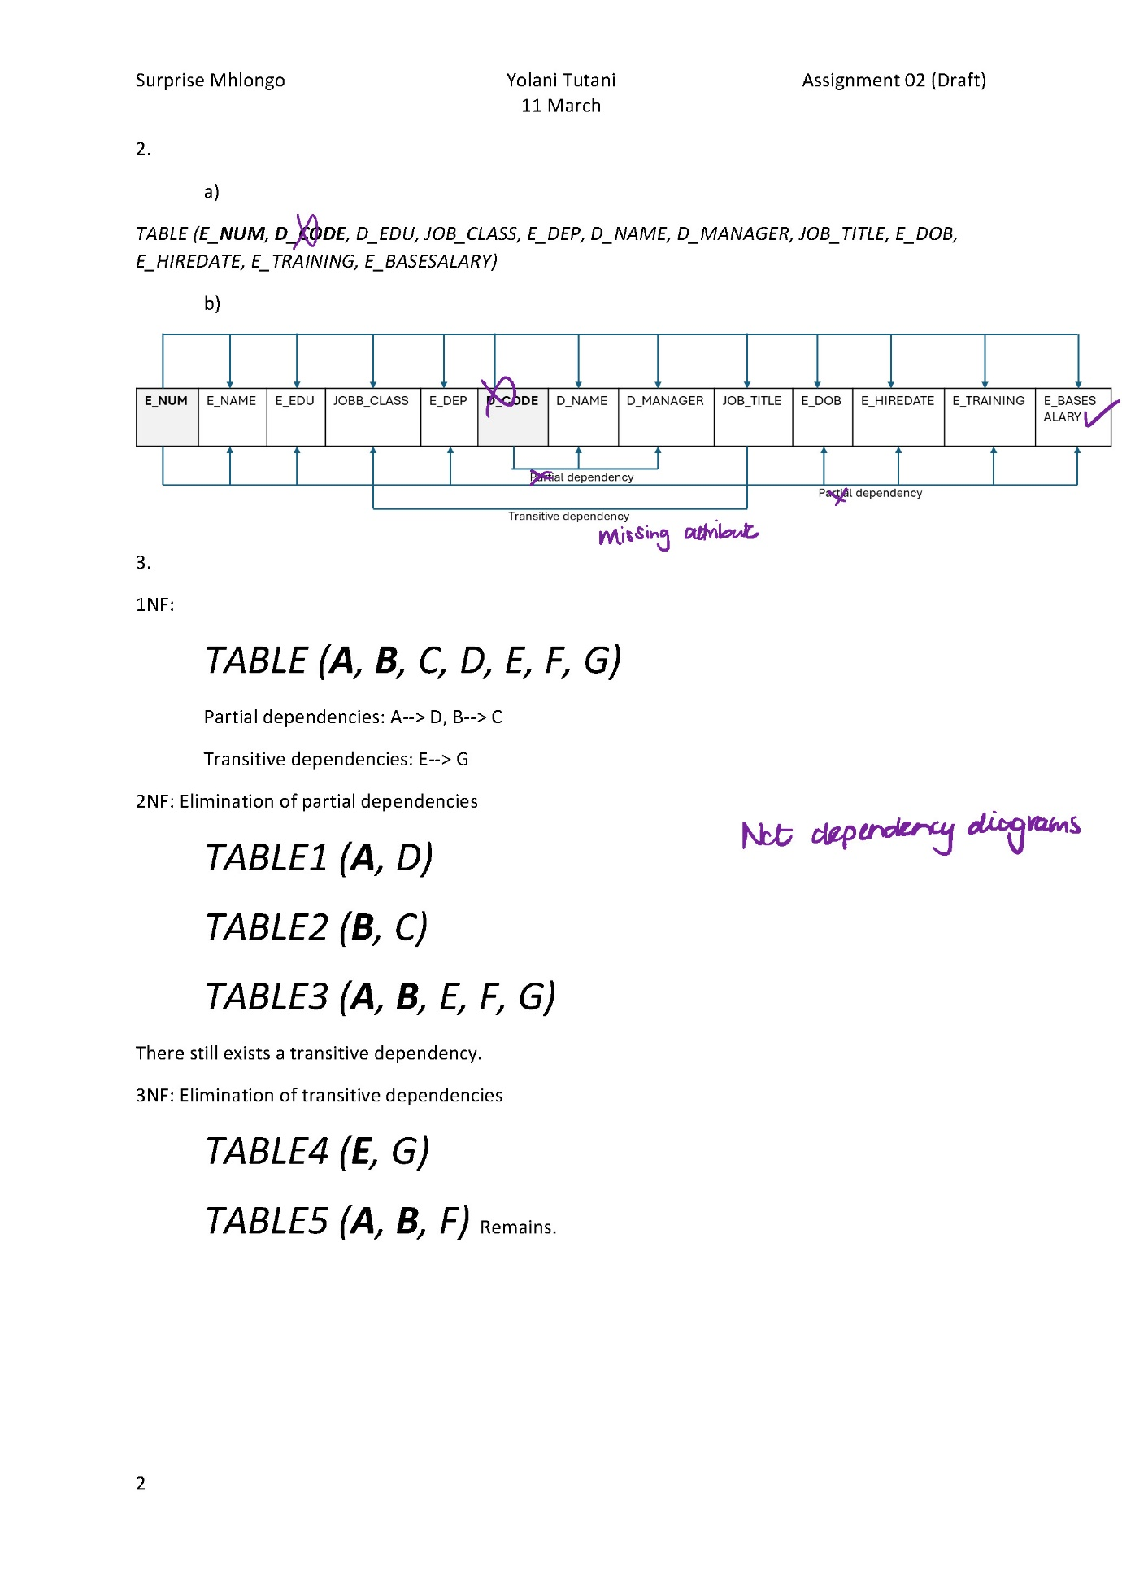

Final Submission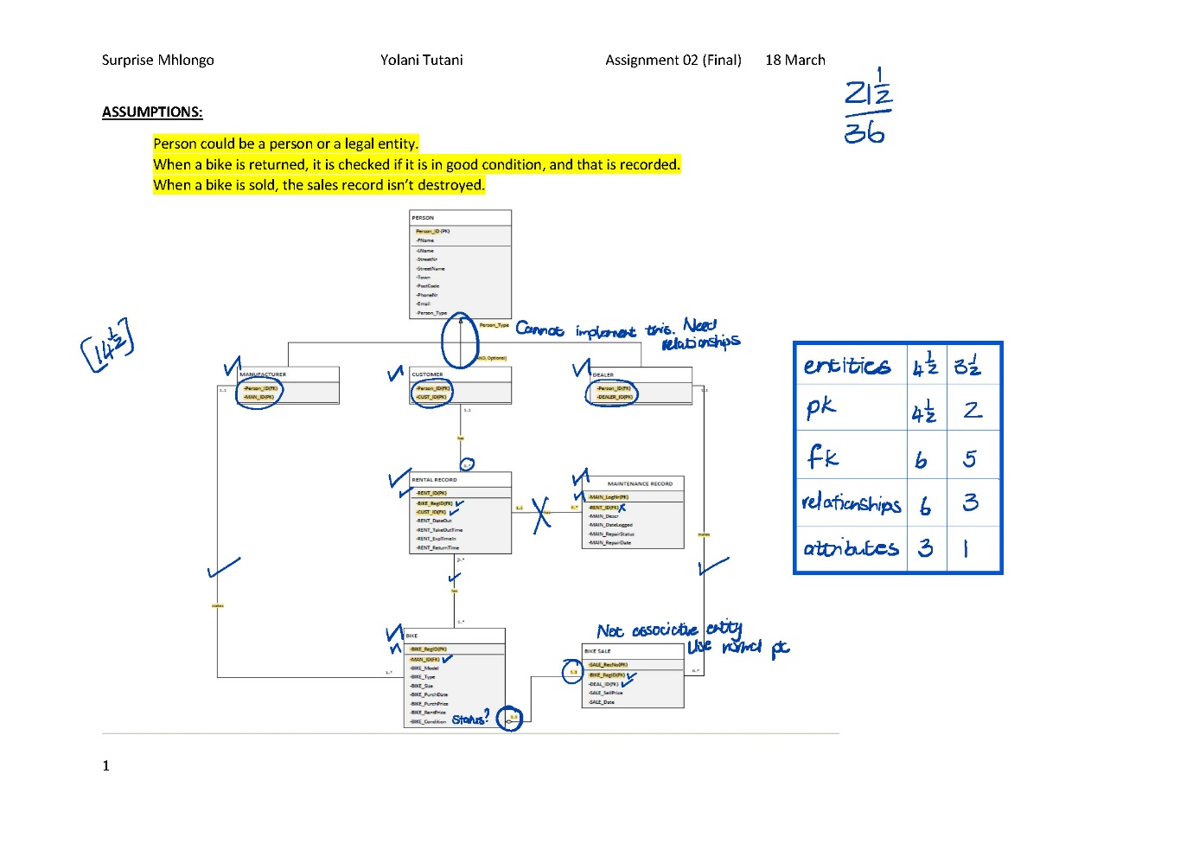

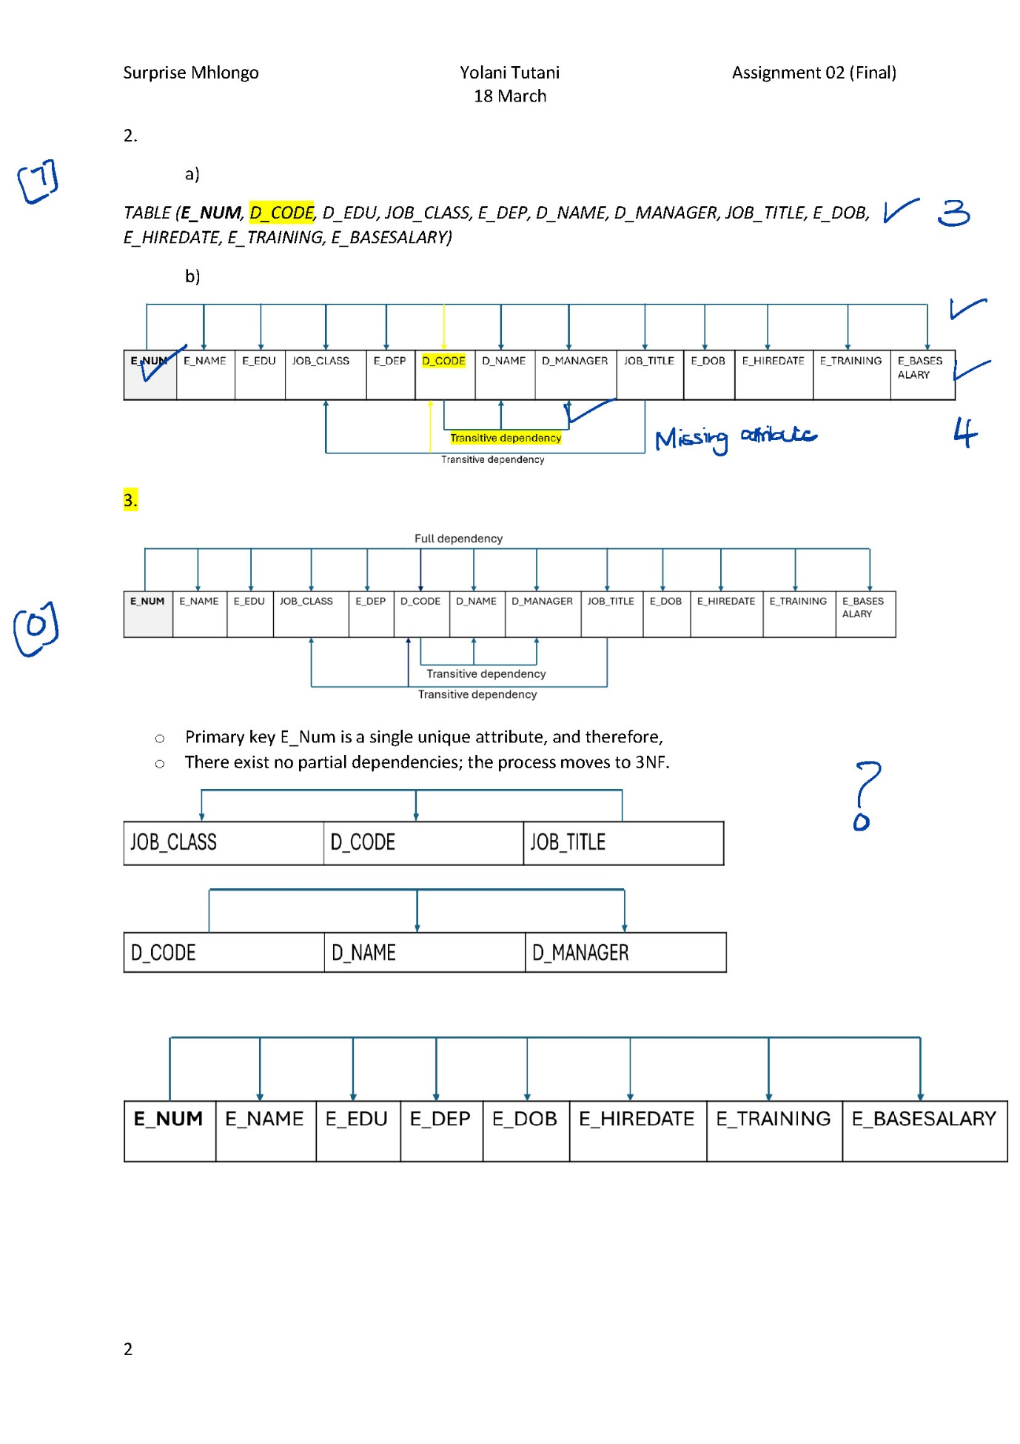

## SQL

Draft Submission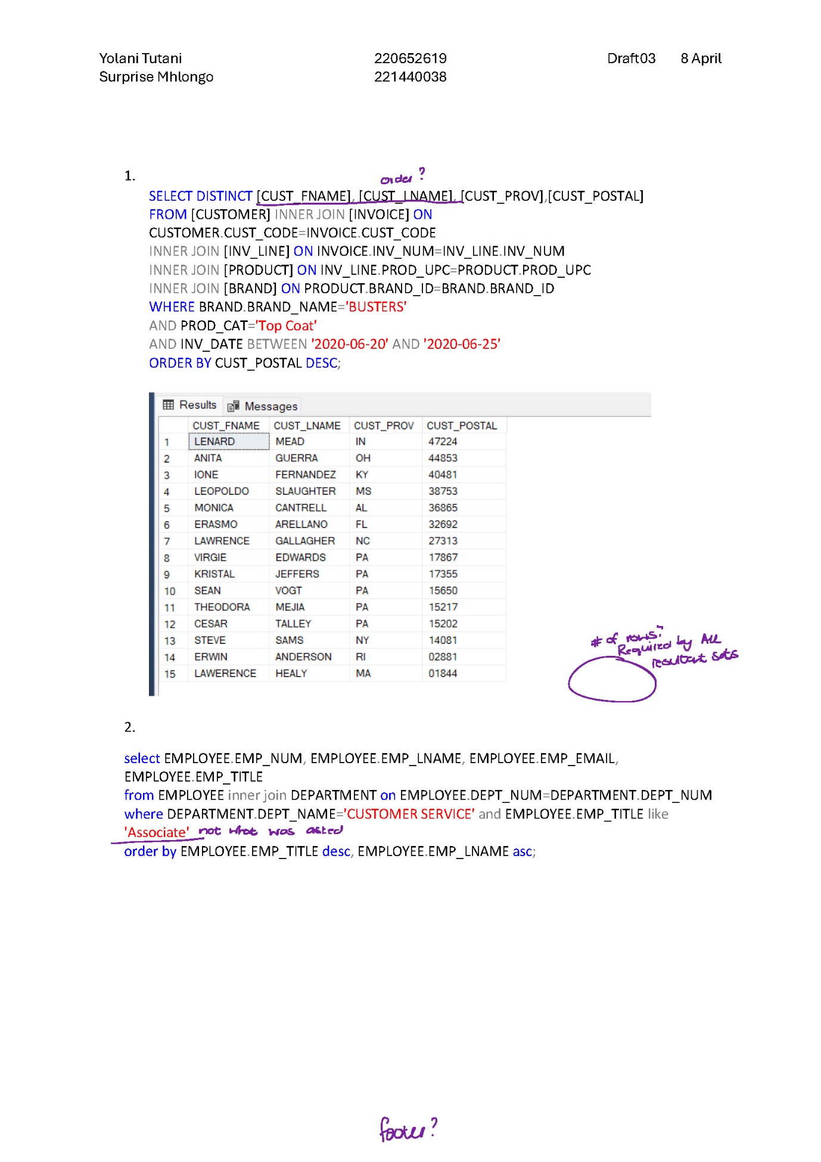

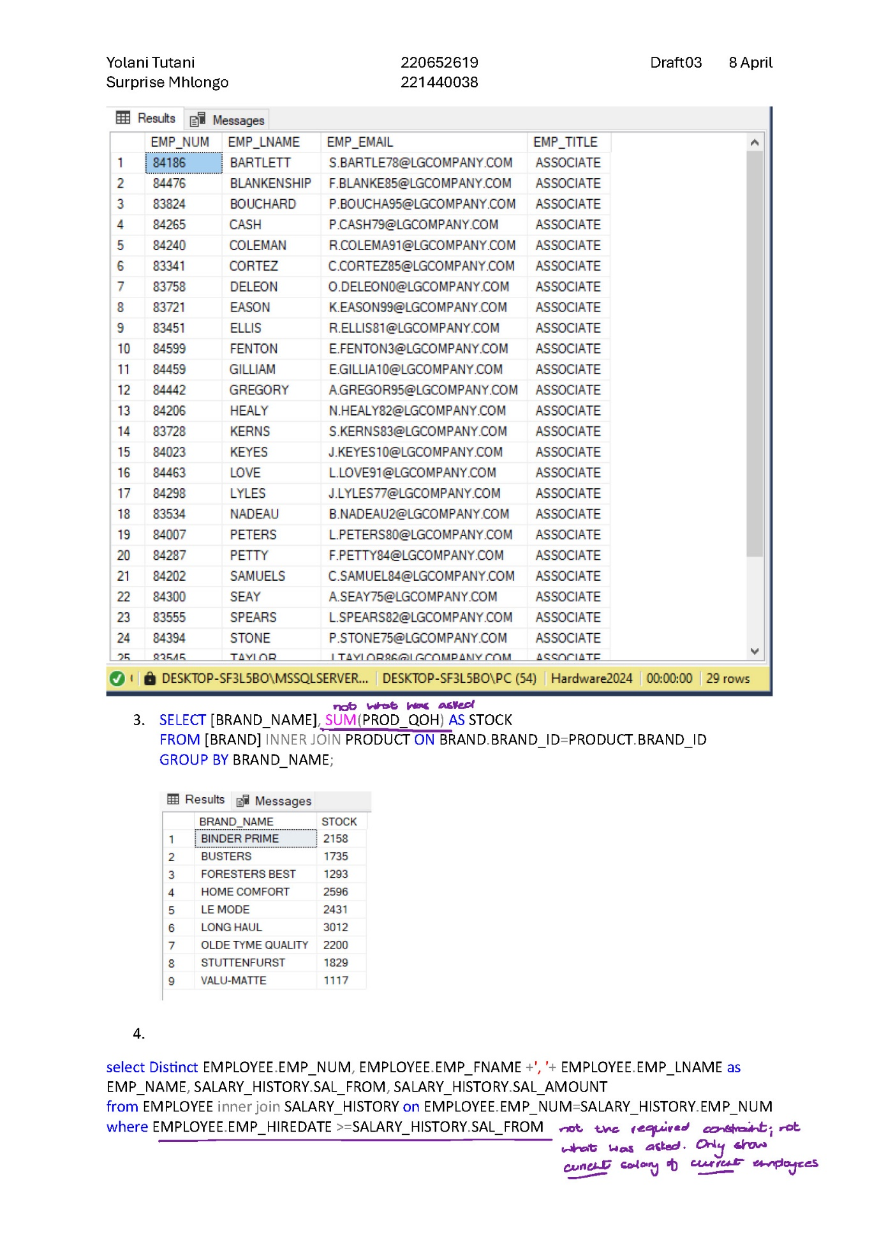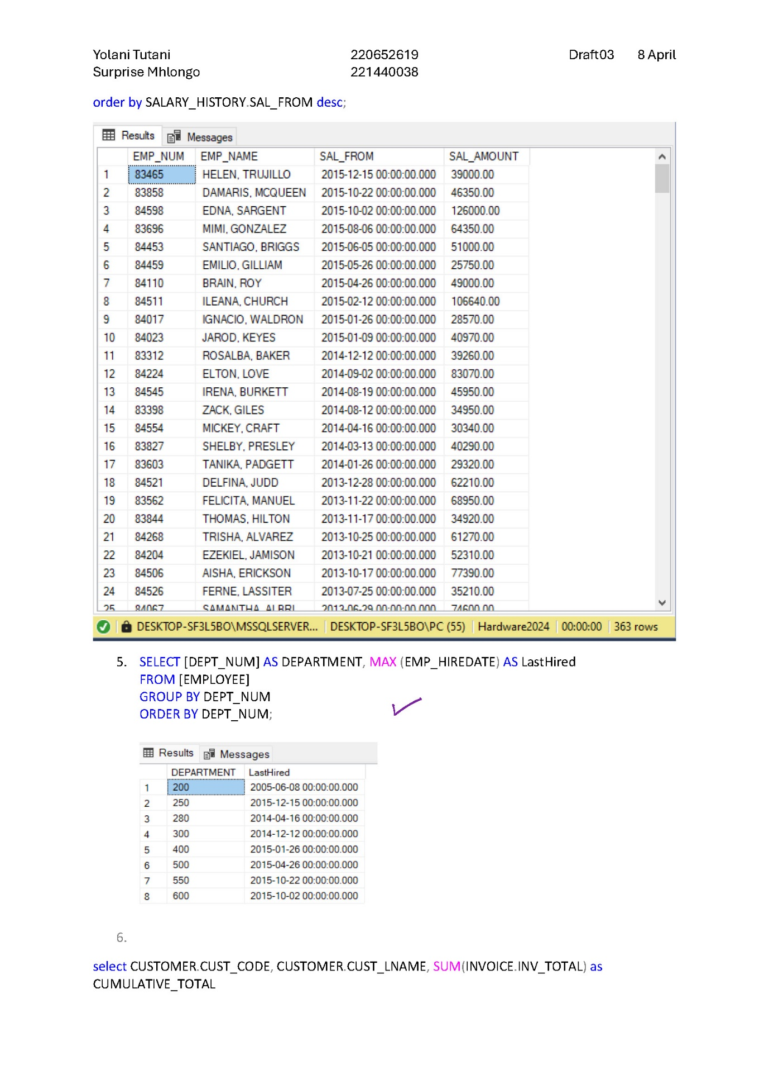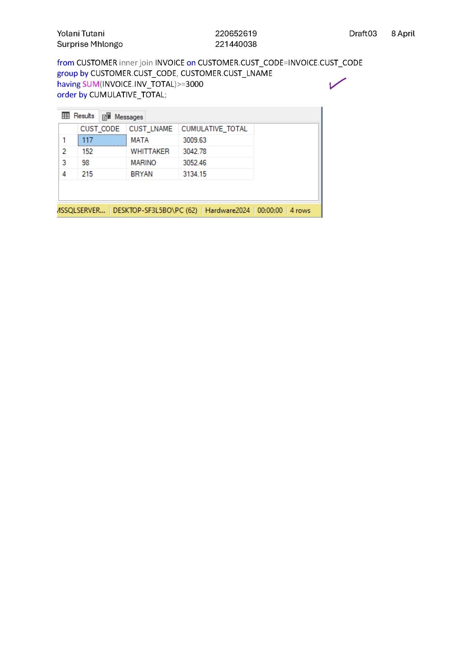

Final Submission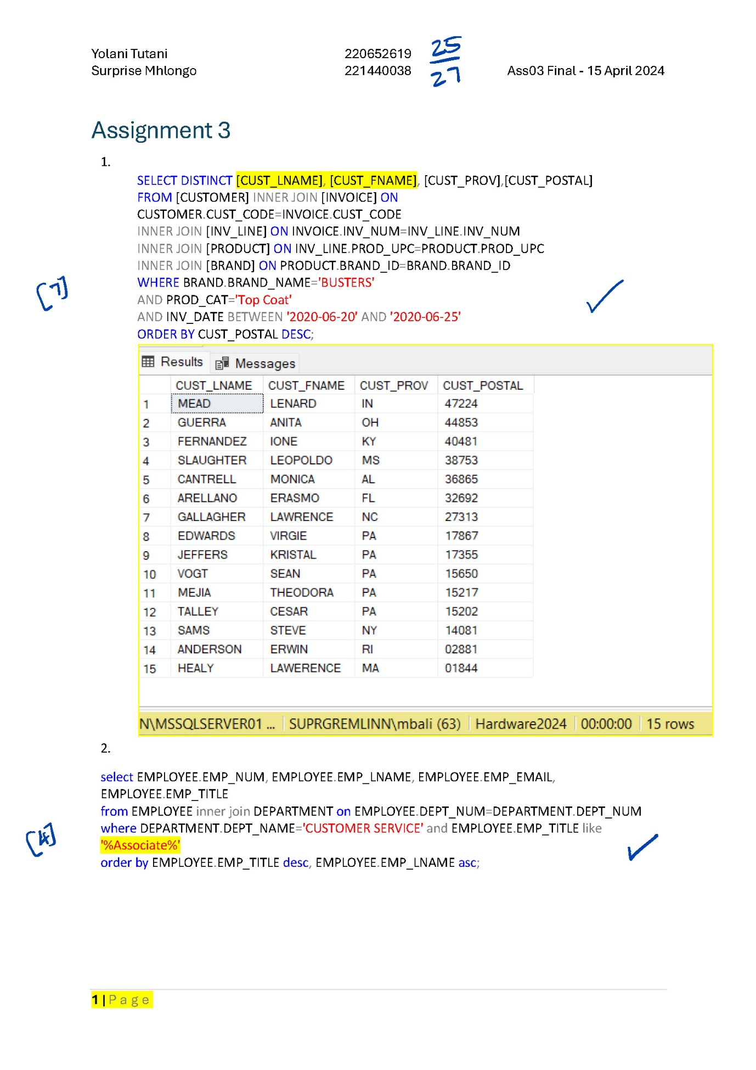

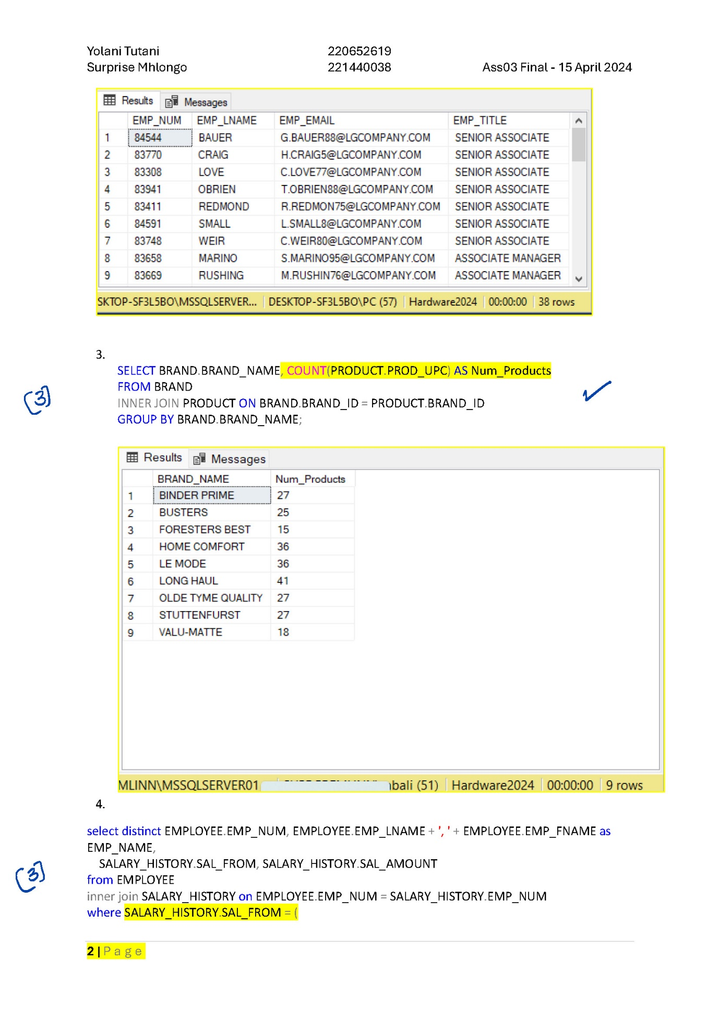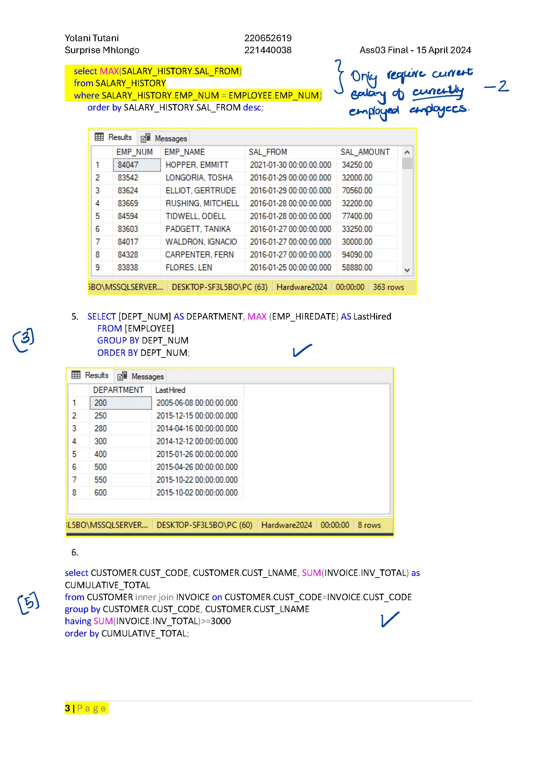

## Database development and design & Concurrency control

Draft Submission

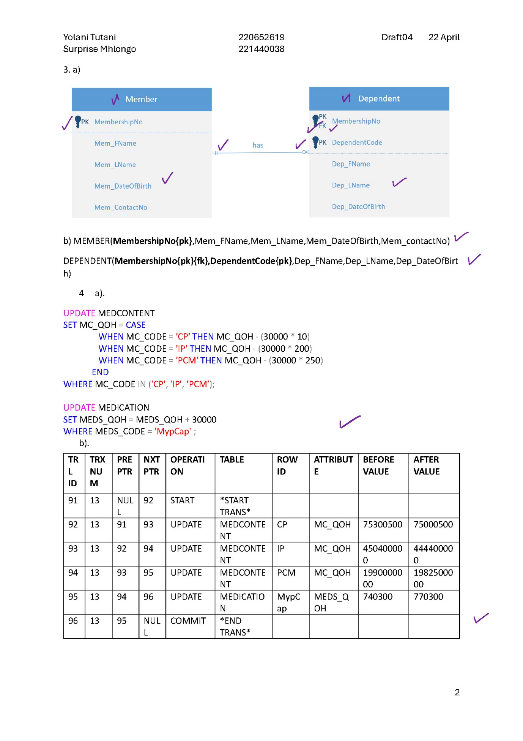

Final Submission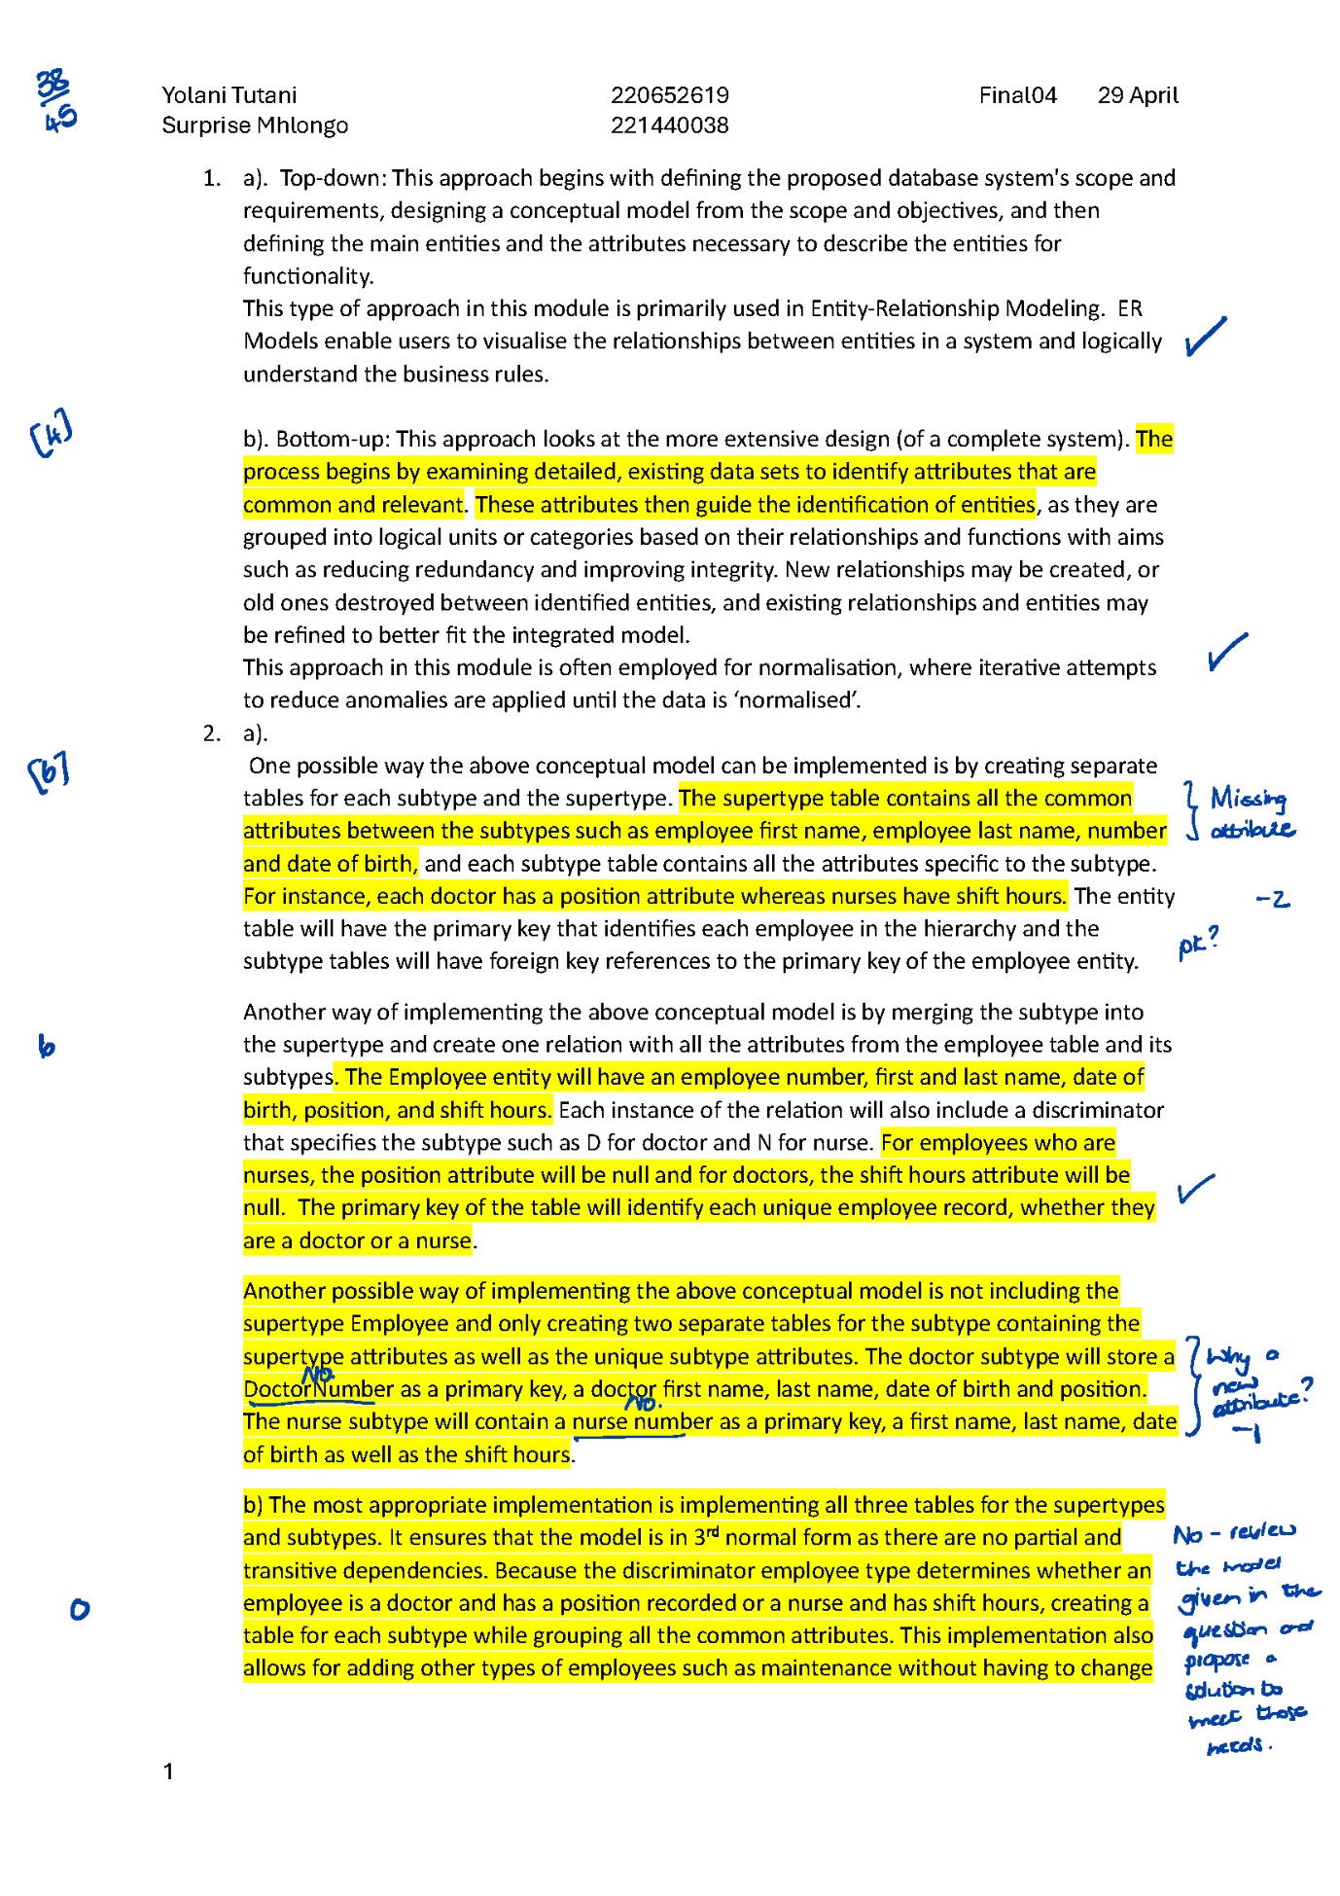

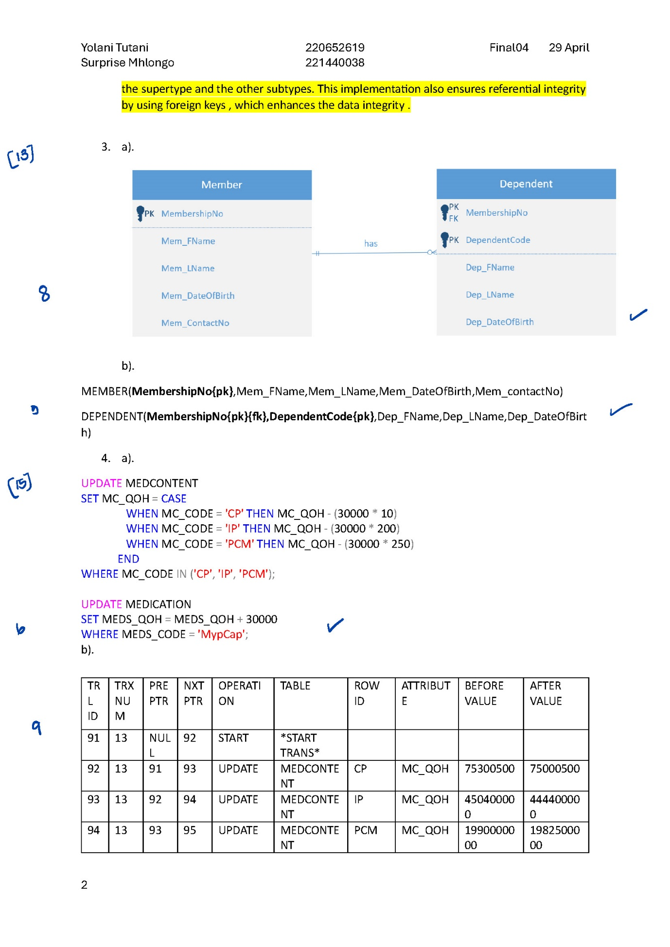

## Managing database and SQL Performance & Distributed databases

Draft Submission 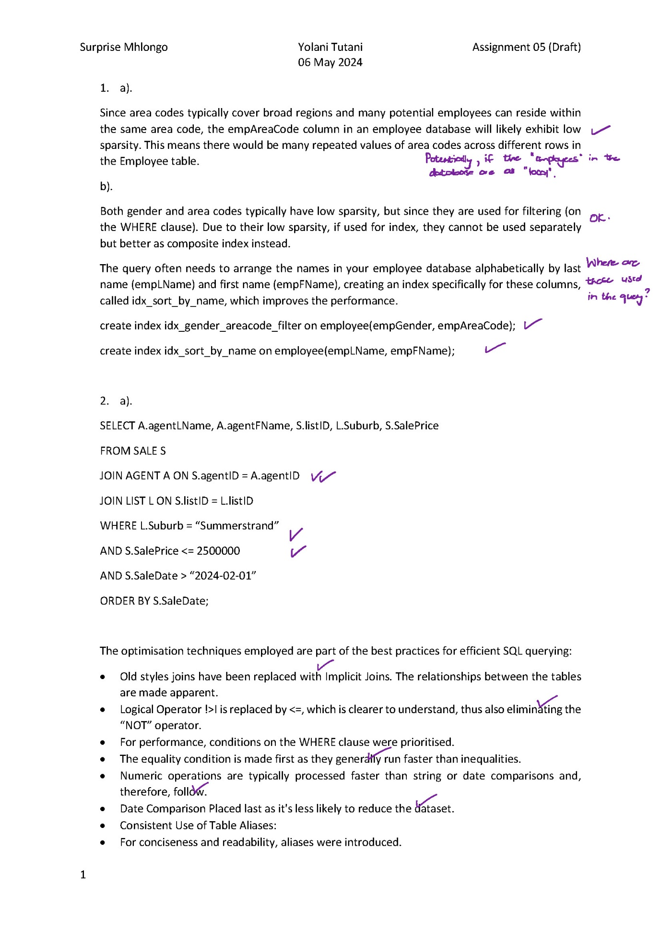

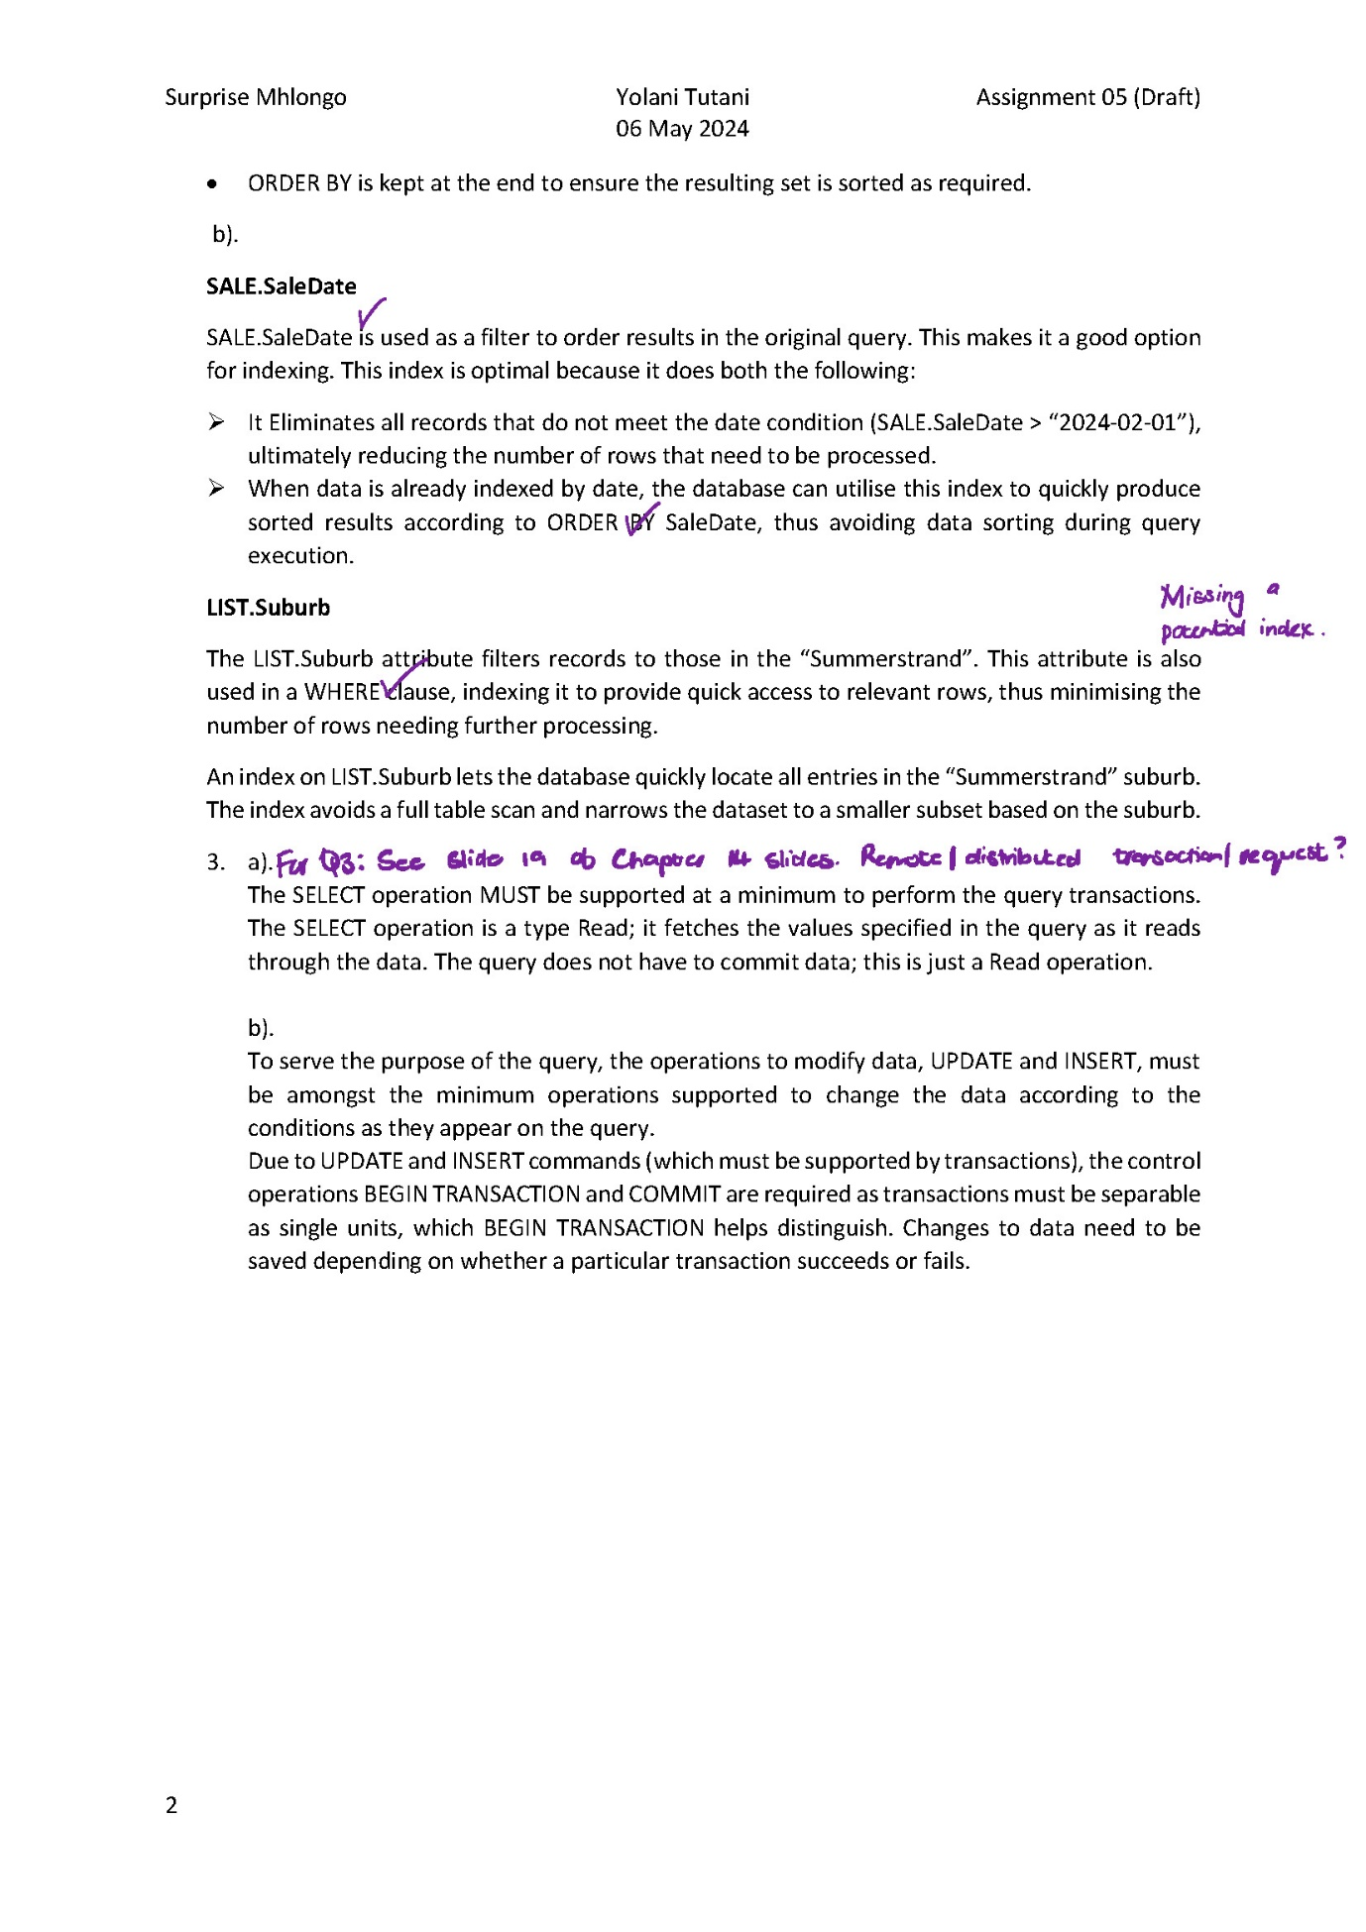

Final Submission 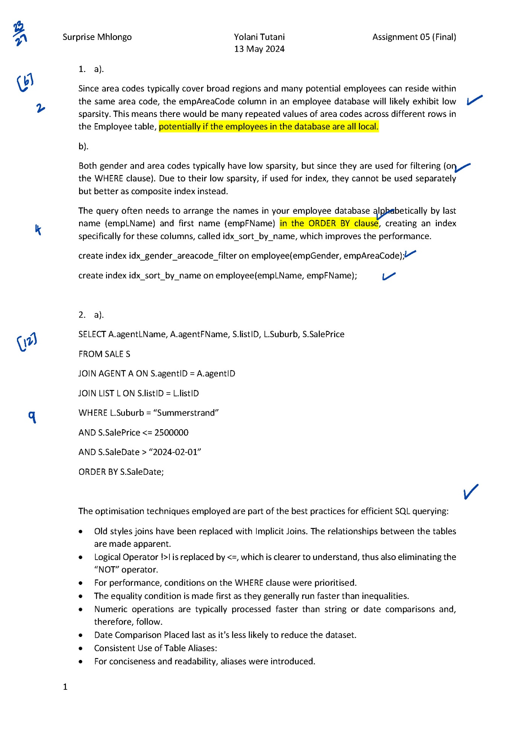

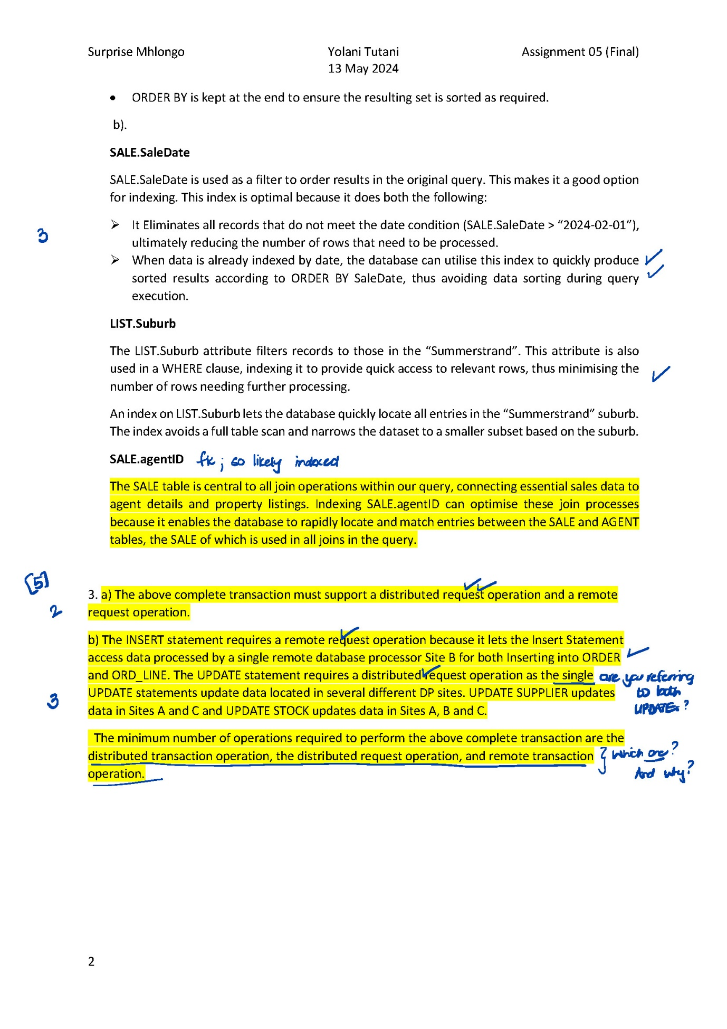

# Reflection

Despite the challenges and time-consuming learning, I have gained a deep appreciation for Database Systems. In this section, I will highlight the most valuable concepts I learned, aspects of the module that were done well, areas that could benefit from improvement, and a significant life lesson I have taken away.

The most valuable concept I learned in this module is SQL. Mastering SQL is crucial for someone pursuing a career in Data Science. SQL enables me to handle datasets efficiently and is a skill I must employ to meet industry expectations as a Data Scientist. This knowledge makes me more effective in managing data and more competitive in the field. SQL's versatility and power in querying databases are fundamental skills for any aspiring data scientist.

One of the aspects of the module that I found particularly well done was the availability of lecture notes and videos ahead of the lectures. This allowed me to prepare in advance for our lectures on Thursdays when I could. Additionally, the strict assessment of submissions and detailed comments were incredibly beneficial. It provided clear feedback on my work, highlighting areas for improvement and encouraging my learning.

However, there were aspects of the module that could be improved. I noticed some ambiguity in the setting of important assessment questions. While the lecturer encourages students to ask questions if they need help understanding certain parts of the assessments, this could be emphasised even more. Language can sometimes be a barrier, and ensuring clarity in assessment questions is essential. There is enough encouragement to seek clarification; perhaps questions should also be exposed to a group of students at an advanced level to check if they find the questions comprehendible.

Throughout this module, I learned the importance of being explicit in my writing and elaborating on concepts rather than generalising. This skill is crucial in academia and professional settings, where clear communication is critical. Additionally, I learned the value of consistency and punctuality. The lecturer’s ethically inclined methods, reliability and schedule adherence have set a standard I aim to emulate in my professional life.

The Database Systems module has been an invaluable part of my educational journey. Mastering SQL has equipped me with essential skills for my future career in Data Science. The strengths of the module, particularly the preparatory materials and rigorous assessments, have significantly contributed to my learning. Addressing the ambiguities in assessment questions could further enhance the learning experience. The life lessons of clear communication, consistency, and punctuality are principles I will carry forward in my personal and professional life.